Introduction of virtual simulation equipment
for VR human anatomy
Virtual simulation equipment of human anatomy in the library can provides users with a realistic laboratory learning environment, decompose and view the major systems and corresponding concepts, and contribute to anatomical learning.
Before using the VR equipment, please contact relevant teachers in the library to apply for and fill in relevant materials. After completing the application, you can enter the VR operation room for operation.
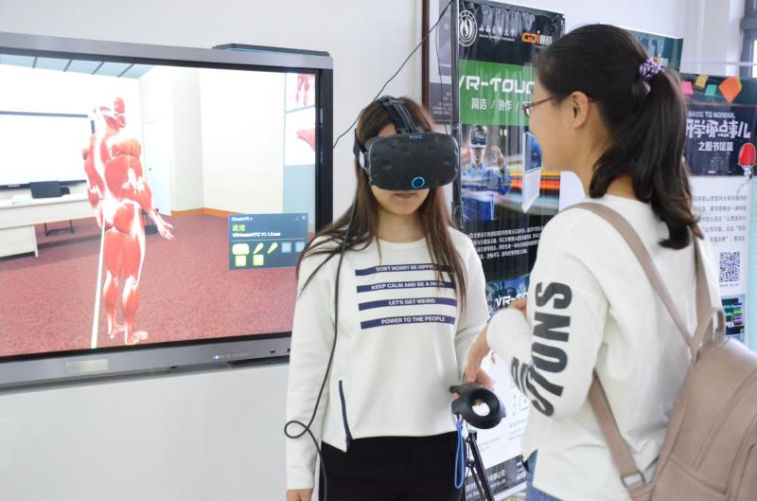
Firstly, switch on the power supply of the VR device, turn on the switch of host and display, and select the HDMI interface (with green highlights) from the Settings menu of the large-screen display. Double-click the screen to confirm.
After that, select the Steam VR icon in the VR interface, double-click to open it, and launch the positioning headset, infrared connection with the machine and handle. Long press the power on button of the headset to open the headset. The headset sensor will track and locate your position in space through the locator.
Long press the system button of the operating handle to open the operating handle and make the head-mounted display, locator and operating handle match with the VR device successfully.
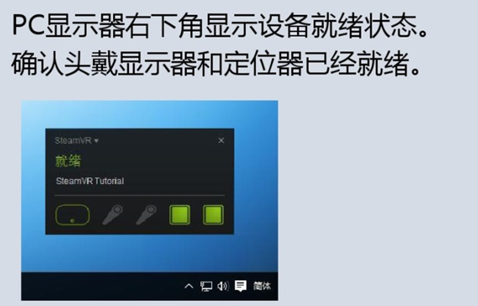
Finally, double-click the icon of the human anatomy software to run.
After opening the human anatomy software, you can select the muscle system, skeletal system, nervous system, digestive system, circulatory system, etc. After selecting any one of these systems, the internal organs can be dragged to the front or the back of the target organs or other positions just by aiming at the organ and pulling the trigger. By pressing the left and right of the touch pad of the control handle, the target can be rotated left and right. When you Press the up and down buttons of the touch pad, the target can be moved up or down.
After completing the operation, please tidy up the helmet handle and communicate with the relevant teacher. The teacher will put the helmet and other devices in the appropriate position, and the VR experience will be over.
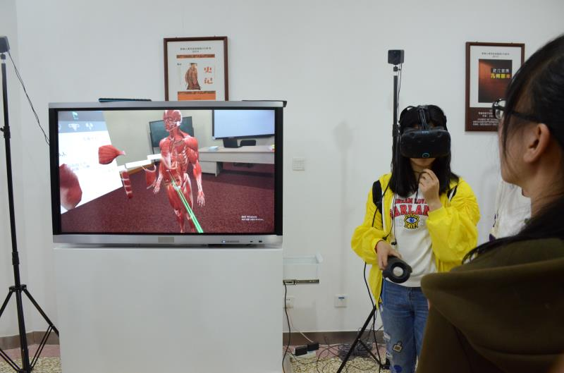

Contact number :0351-3985193 Mr. He

