Instruction of Electronic resource touch screen
一、A guide to e-book readers(bookan)
The new campus of the library is equipped with three mobile e-readers, which can provide our readers with free mobile reading of about 3,000 e-books and keep them updated every month. E-book categories include: boutique recommendations, classics, health care, financial management, inspirational success, fiction biography, literature and art, history and military, humanities and social sciences, political law, philosophy of life, etc.
As long as the reader installs the APP of super star mobile library on the mobile device (mobile phone or Pad that supports android or ios system), they can read e-books conveniently on the lending machine.
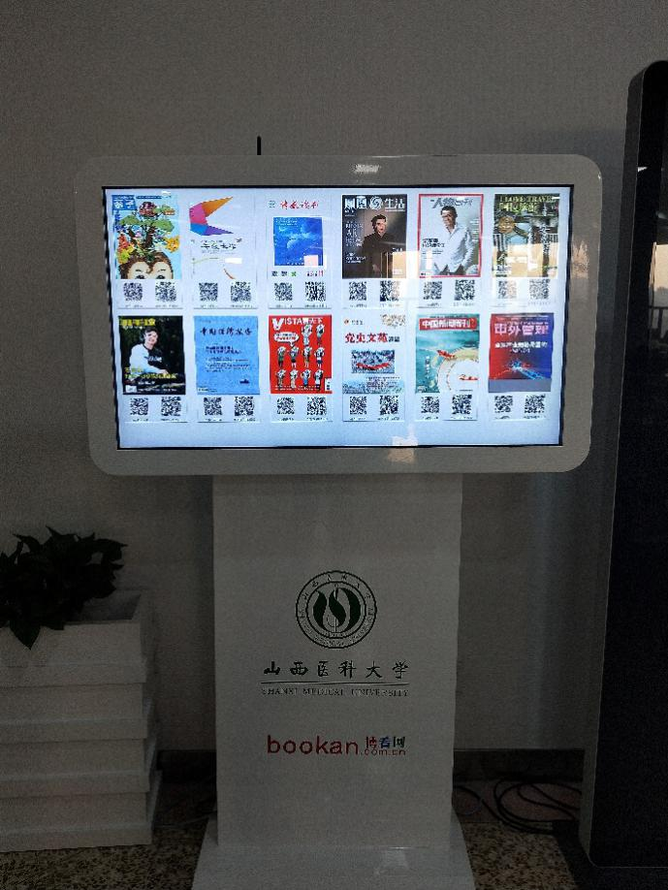
The specific usage is as follows:
1. Click the standby interface of the borrower, enter the home page, and click the "instructions" in the upper right corner.
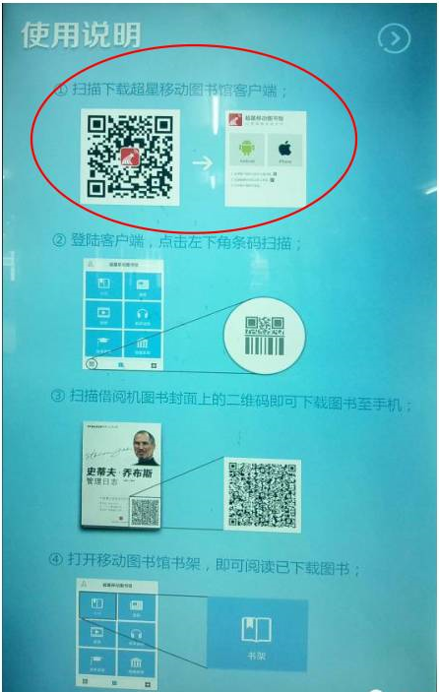
2. Mobile phone scan and download the dedicated reading client, and register the mobile library.
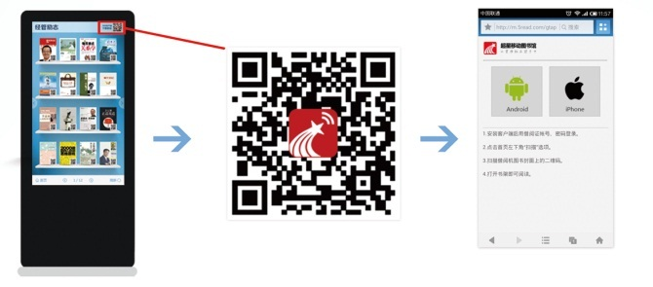
3. Click the touch screen of the borrower and select the book you want: start the mobile client "scan"
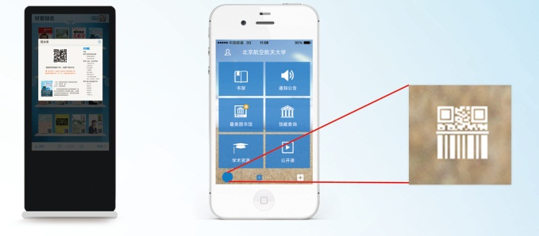
4. Scan the QR code on the book cover of the lending machine and download the book and you can save it to the "shelf" of the mobile library.
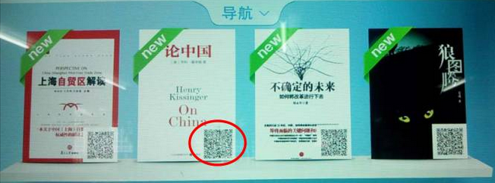
5. Find the downloaded e-books in the "bookshelf" to open and read.
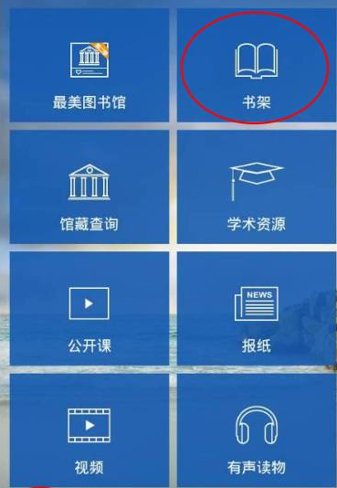
二、Newspaper reader instructions
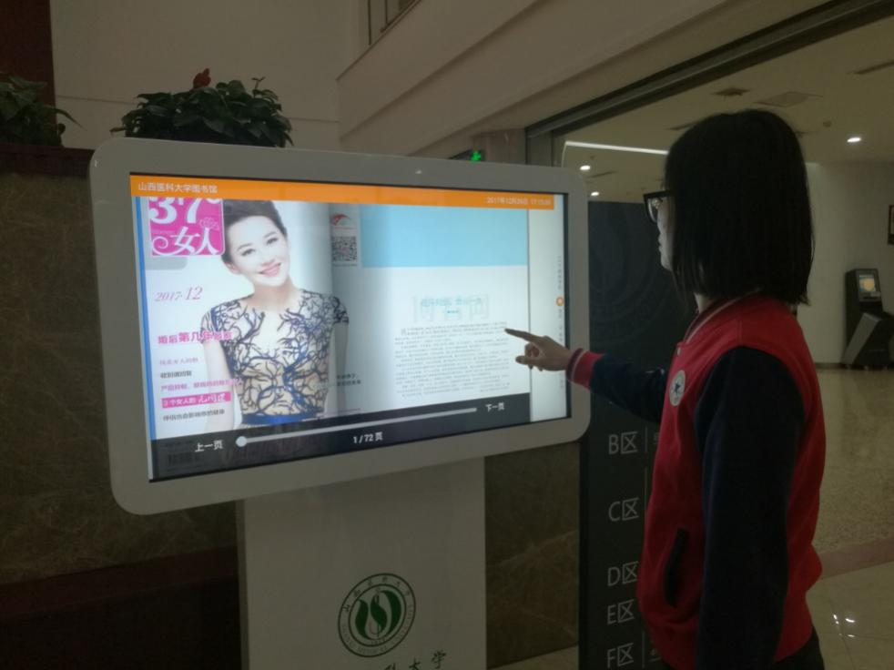
1. Select the content you want to browse on the home screen.
2, take the slide page or turn the page to read the newspaper.
3. You can also browse the library through the newspaper reader.

