Instruction of 24-hour library
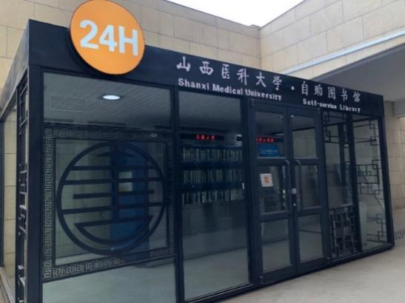
There is a 24-hour self-service machine for borrowing and returning books In the sunken courtyard of the east gate of the library,in which students can go through the procedures of borrowing and returning books at any time .(Books can also be returned when the library is closed).
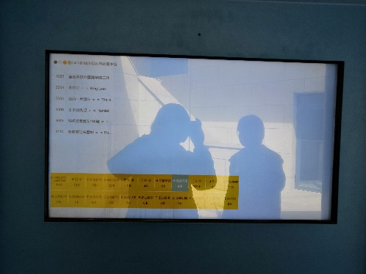
1. Readers can choose to borrow books from the book browsing screen on the left, and record the title of the book or the location number of the book.

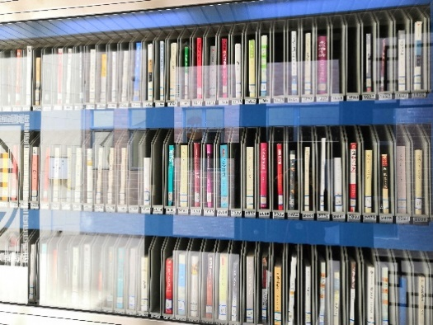
2. Reader can browse and select the books that reader want to borrow in the visual window in front of the product, and record the title of the book or the location number of the book.

3.Reader can be in the right side of the product query machine, check whether there is the book that reader want.If Yes reader can go to the front of the operating table to borrow the book
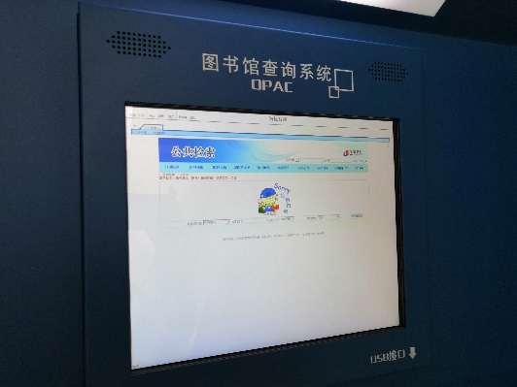
Borrow books process:
1. Click the "borrow or return the book" button, wait for the reader to brush the reader card, then enter the function interface :(after swiping the card successfully, remember to take away the library card, and input the password of the reader card according to the system prompt. (The initial password is the date of birth of the 8 digits on the id card.)
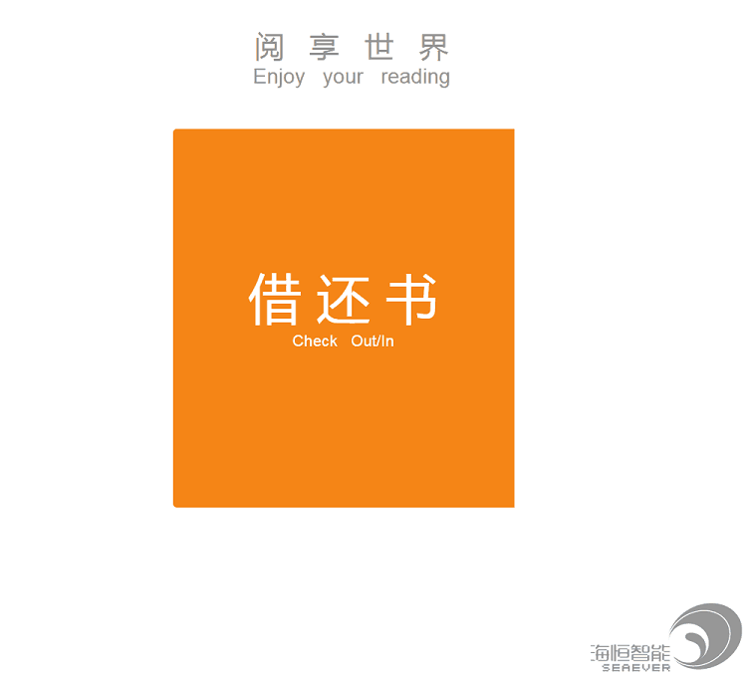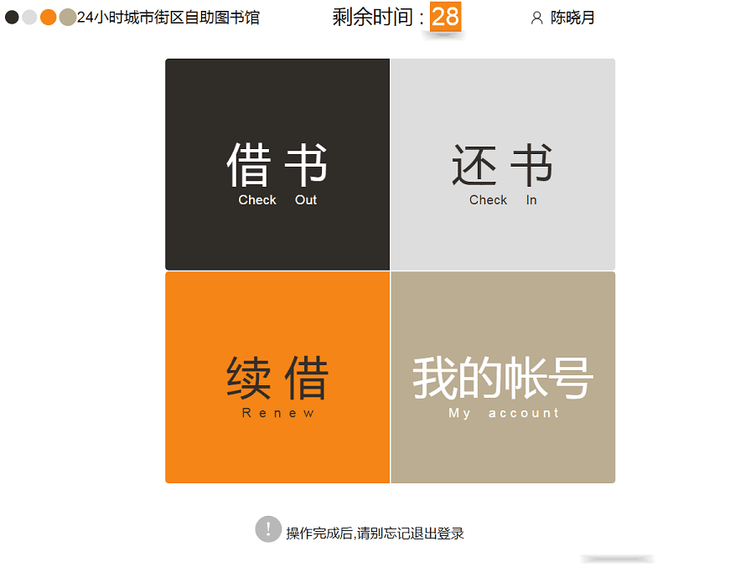
2. Click the "borrow books" button, input the location number of the book reader want to borrow, and then the interface will display the information of the book and the shelf number. Click the "borrow books" button after reader have confirmed, and the system will prompt reader to borrow books successfully. (Only one book can be borrowed at a time, if reader want more than one book, repeat above steps.)
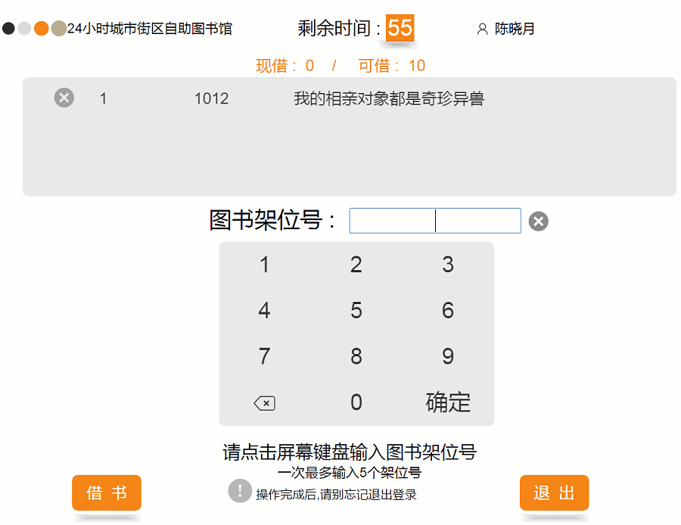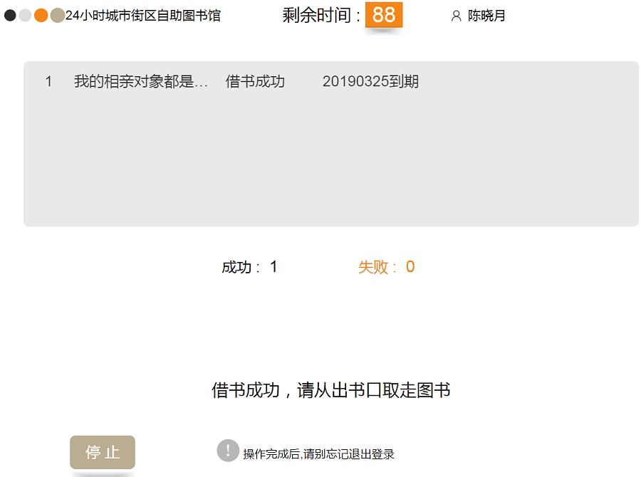
Return the book process:
Reader should brush the reader card to enter the function, click the "return the book" button, then the the door of the device will be open,reader could puts the book in it according to the prompt. As shown in the figure below, the system prompts reader to return the book successfully and reader can return it. (note: when returning the book, the book should be placed in the front of the book return port, and only one book can be returned per operation).
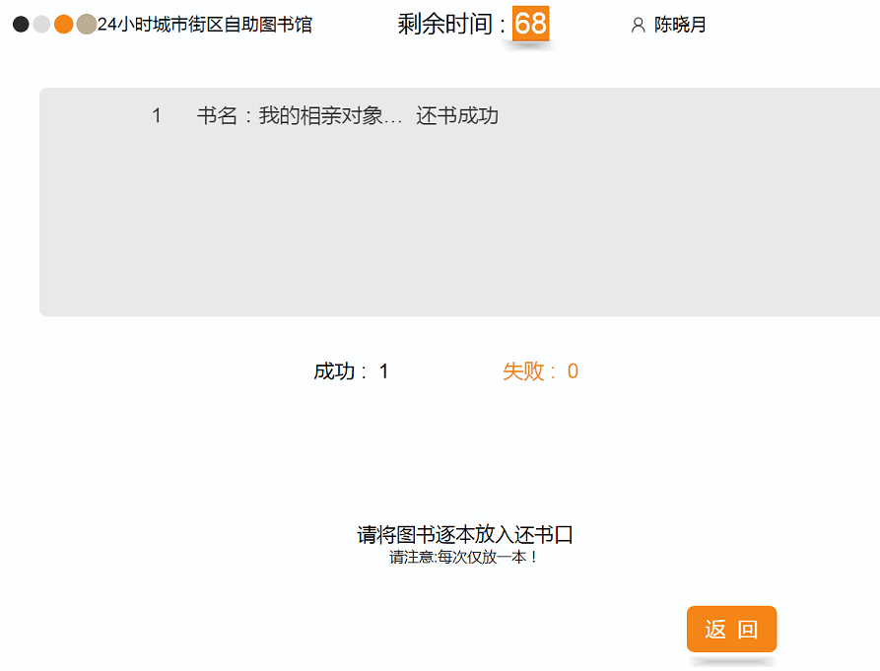
Renew process:
The reader swipes the reader card to enter the function, clicks the "renew" button, checks the book that needs to be renewed, clicks the "renew" button, the system prompts to renew successfully, and returns.
