Instrucion of Manual for self-help book return machine
The library is equipped with a self-help machine for borrowing and returning books. Students can help themselves to deal with the procedures of borrowing and returning books here.
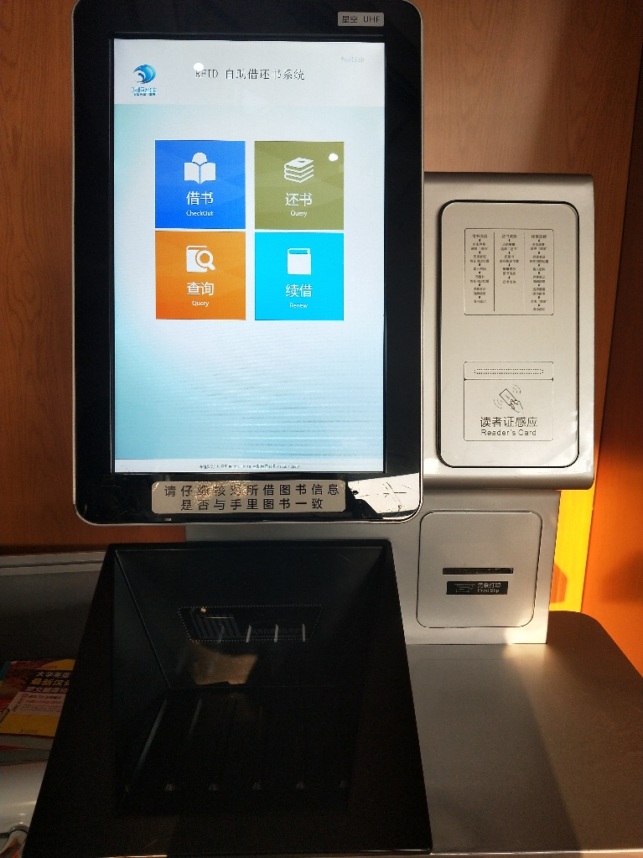
Borrow books process：
- Click the "borrow books" button to start borrowing。
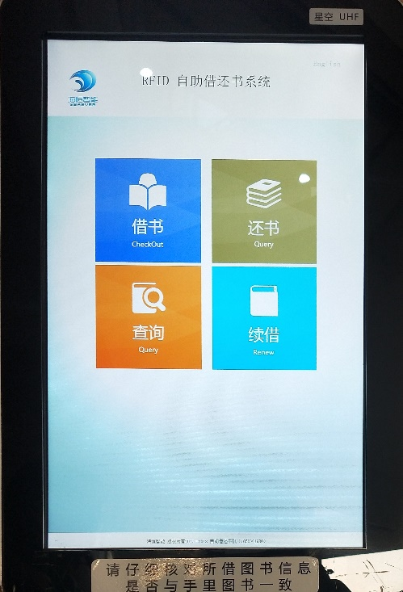
2.Please place your library card in the "barcode scanning area" at the bottom left of the screen.
Pay attention to the bar code number facing up after swiping the card successfully, remember to take away the library card (if you forget to take it, you can try to find it at the service desk). According to the system prompt input the password of the reader card, the initial password is the date of birth.
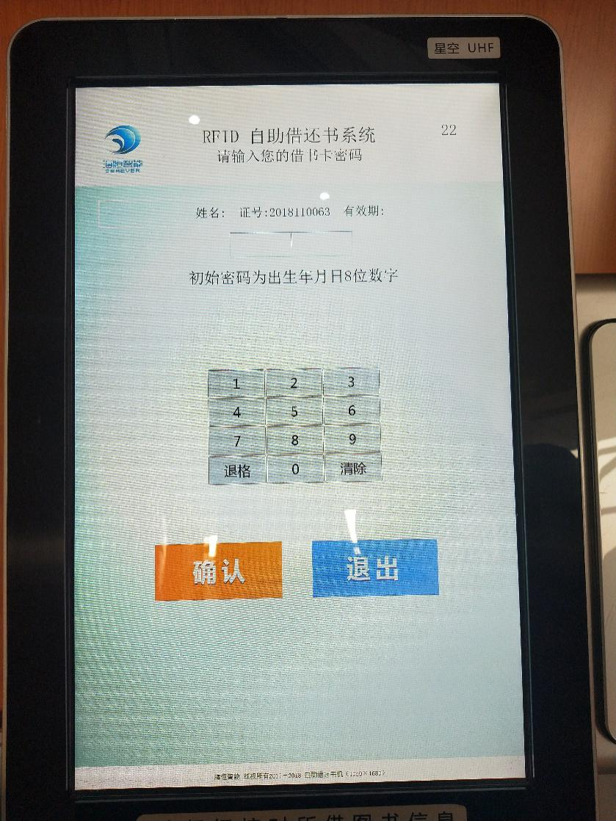
3. Select the number of the book you want to borrow ,which can be more than one, or divided into multiple loans. If you choose the wrong number, you can return the reselected number.
Place the book vertically in the slot below the screen (it can also be put freely, our device is very powerful '(*∩_∩*) but please check the information).
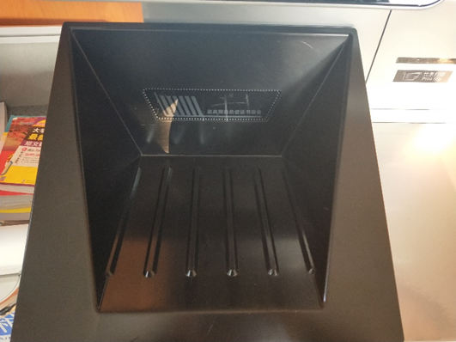
4. When verifying the number of books displayed by the computer and the titles of the books that are actually borrowed (do not lend the books of the students behind you to your card), the system prompts you to pay attention to the date to be returned after all borrowing is successful, in case of overdue, choose "exit".
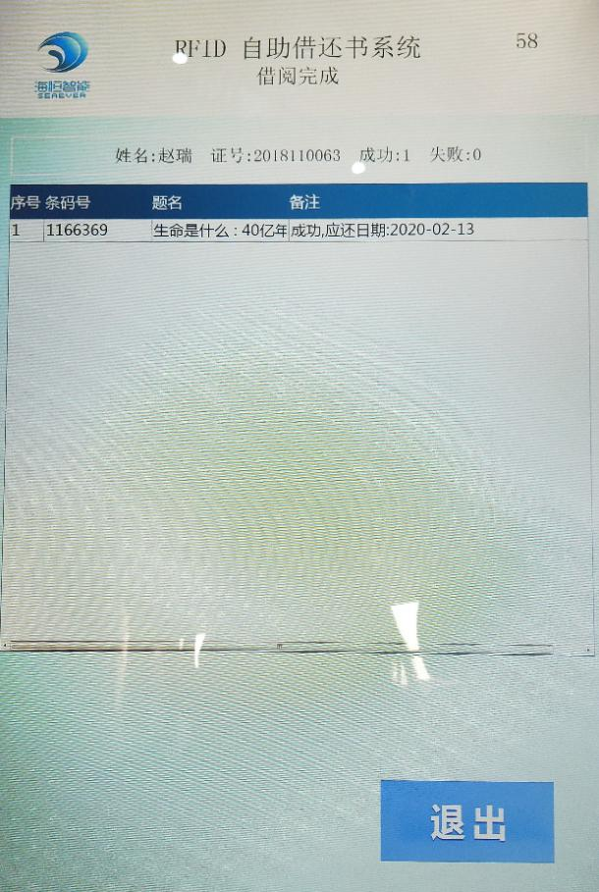
Return process (no need for library card)：
1. Click the "return the book" button to return the book.
2. Choose the number of books to return. If you choose the wrong number, you can return the reselected number.
3. Place the returned book in a slot at the bottom of the screen
4. When verifying that the number of books displayed on the computer and the titles match the actual books to be returned, select "confirm return of books".
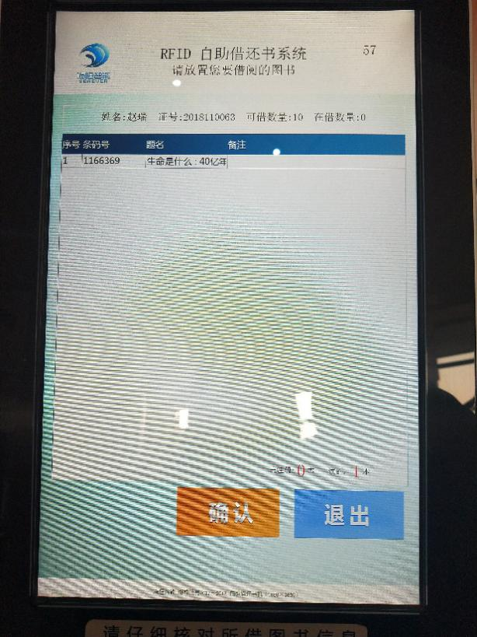
Renewal process:
1. Click the "renew" button to renew
2. The method of placing library CARDS is the same as the function of borrowing books. After the card is swiped successfully, remember to take away the card and the enter the password of the card according to the system prompt.
3. Choose to renew books. If it can be renewed, the "confirm renewal" button is blue, otherwise it will be prompted and cannot be renewed. The operation completes and exits. Please note that the date should be returned!
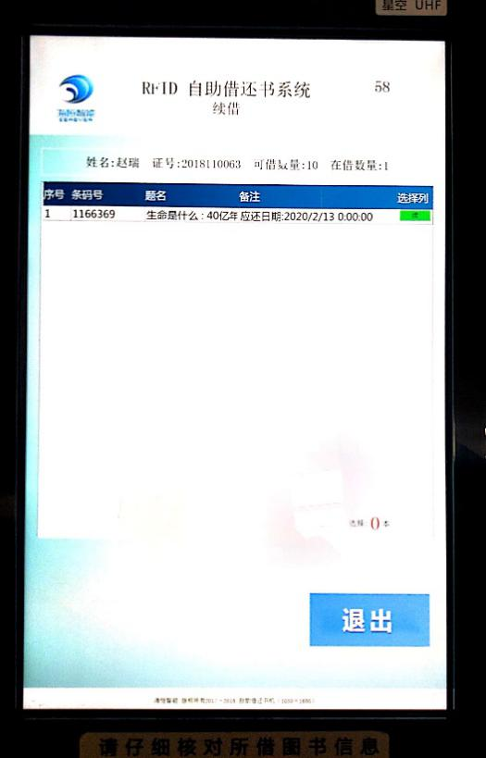
Borrowing inquiry process:
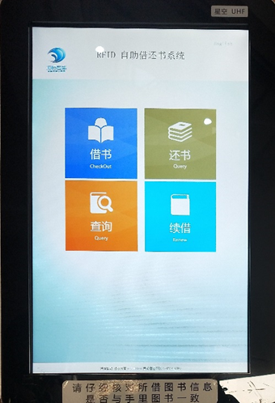
1. Click the "borrowing inquiry" button to start the inquiry.
2. The method of placing library CARDS is the same as the function of borrowing books. Enter the password of the card according to the system prompt and then take away the card after the card is swiped successfully.
3. Check the number of books displayed on the computer, the title of the book and the actual borrowing of the book match, query completed, select "exit".

